AIR QUALITY MONITORING

Introduction:
Air quality monitoring based on IOT (Internet of Things) involves the use of interconnected sensors and devices to continuously collect and analyze data related to the quality of the air in a specific area.

Components:

No. of Components | Components Used | Working Principle of Components and Uses of the Components
1 | Arduino Uno | The Arduino Uno for air quality monitoring reads data from sensors (e.g., gas or particulate matter sensors), processes it through code, and provides real-time or logged air quality information based on sensor readings.
2 | OLED display | OLED (Organic Light-Emitting Diode) displays in air quality monitoring visually represent real-time air quality data by emitting light from organic compounds, enabling clear and energy-efficient data visualization.
3 | Matrix keypad | A matrix keypad on an air quality monitoring system allows user input for configuration or data retrieval by assigning unique codes to various functions or settings using rows and columns of buttons.
4 | Buzzer | A buzzer in air quality monitoring typically emits sound alerts when air quality thresholds, predefined in the monitoring system, are exceeded, providing a real-time auditory indication of poor air quality.
5 | Transformers | Transformers in air quality monitoring step up or down voltage levels to power sensors and communication components efficiently, ensuring accurate measurements and data transmission while isolating the sensors from power supply variations.
6 | Regulator circuitry | A regulator circuit in air quality monitoring stabilizes voltage to ensure consistent sensor performance and accurate measurements.
7 | Switches | Switches in air quality monitoring systems are used to control power, activate sensors, or trigger alarms, typically by physically interrupting or connecting electrical circuits based on predefined conditions or user inputs.
8 | LED’s | LEDs in air quality monitoring systems are used to visually indicate air quality levels based on predefined thresholds, with different colors (e.g., green for good, yellow for moderate, red for poor) corresponding to specific pollutant concentration ranges.
9 | PCB board | A PCB (Printed Circuit Board) in air quality monitoring acts as the central platform to connect and integrate sensors, microcontrollers, and components, facilitating data collection, processing, and transmission for accurate air quality measurements.
10 | Resistors | Resistors in air quality monitoring are used to measure changes in electrical resistance caused by gases, providing a basis for gas concentration detection through resistance changes.
11 | Capacitors | Capacitors in air quality monitoring act as energy storage components, helping to stabilize sensor readings and filter out noise from power supplies, contributing to more accurate and reliable measurements.
12 | Transistors | Transistors in air quality monitoring amplify and control electrical signals from sensors to measure and analyze air quality parameters such as gas concentrations, allowing for data collection and analysis.
13 | Cables and Connectors | Cables and connectors on air quality monitoring systems transmit sensor data from various sensors to the central monitoring unit, enabling real-time data collection and analysis for assessing air quality.

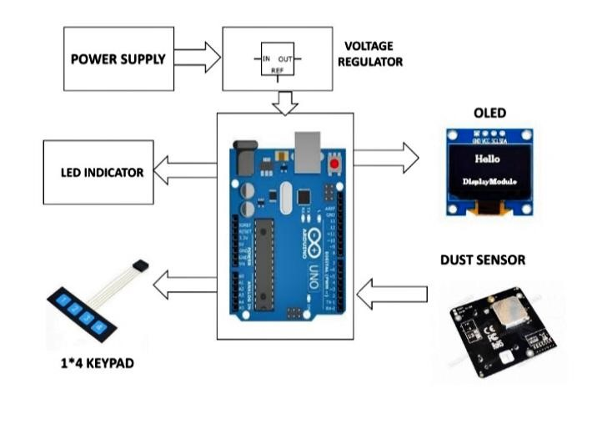
Block Diagram:

Procedure:
Airborne particulate matter (PM) is Air quality monitoring using IoT offers real-time data collection and analysis, enabling prompt pollution control measures. It enhances public health by providing accurate air quality information. IoT sensors and data analytics improve the efficiency of air quality management systems. This technology helps identify pollution sources, aiding in targeted interventions. Overall, IoT-based air quality monitoring contributes to cleaner and healthier environments. not a solitary pollutant, yet rather is a combination of numerous chemical compounds. It is a mind boggling combination of solids and vapor sprayers made out of little drops of fluid, dry strong parts, and strong centers with fluid coatings. Particles change generally in size, shape and chemical piece, and may contain inorganic ions, metallic mixtures, elemental carbon, natural endlessly compounds from the world’s outside layer. Particles are defined by their diameter for air quality administrative purposes. Those with a diameter of 10 microns or less (PM10) are inhalable into the lungs and can actuate antagonistic wellbeing impacts. Fine particulate matter is defined as particles that are 2.5 microns or less in diameter (PM2.5). In this way, PM2.5 includes a part of PM10.
PM10 and PM2.5 frequently derive from various emissions sources, and furthermore have different chemical compositions. Emissions from ignition of gasoline, oil, diesel fuel or wood produce a large part of the PM2.5 contamination found in outside air, as well as a critical extent of PM10. PM10 likewise incorporates dust from building destinations, landfills and farming, out of control fires and brush/squander consuming, modern sources, wind-blown dust from open terrains, dust and pieces of microbes.

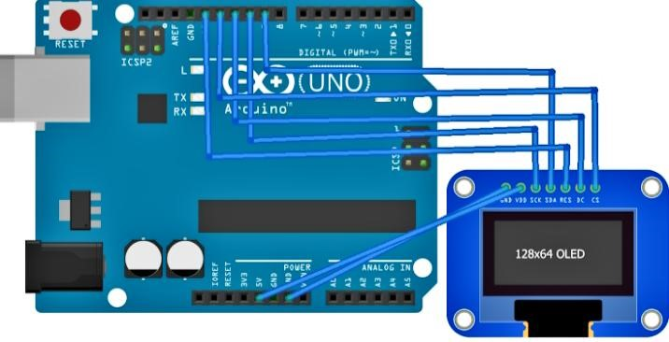

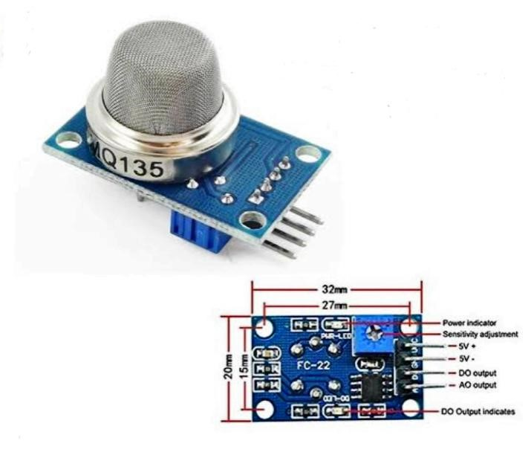
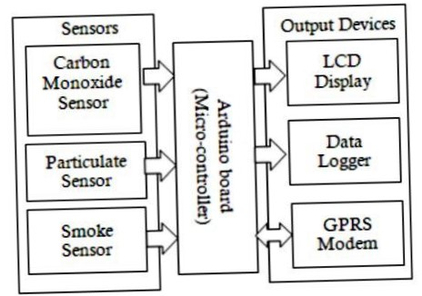
Well the first step to fighting PM2.5 and PM10 pollution is to be able to detect it and monitor it with ease. So we here develop a PM10 and PM2.5 air pollution monitoring system using Arduino Uno. The system makes use of Arduino Uno controller along with an OLED Display, Dust Sensor, Matrix Keypad, switches and buttons along with basic electronics component and PCB to develop this system.
The system when allows user to select one of the two operations:
- Settings Mode
- START/Monitor Mode

The settings mode allows user to set some monitoring and alert parameters in the system. The user can first set the upper and lower limits for PM 2.5 particulate monitoring along with the upper and lower limits for PM 10 particulate monitoring.

When user sets all the stings and navigates to the start monitoring, the system starts analyzing sensor data. The controller constantly senses sensor output to get current PM10 and PM2.5 matter data. This data is also shown on the OLED display for monitoring. As soon as the PM2.5 or PM10 level goes beyond the respective set limits the system sounds a buzzer alert and indicator LED to indicate an alert signal.

This is how the system allows user to live monitor PM2.5 and PM10 pollution data as well as sound alert when it is beyond set limits.

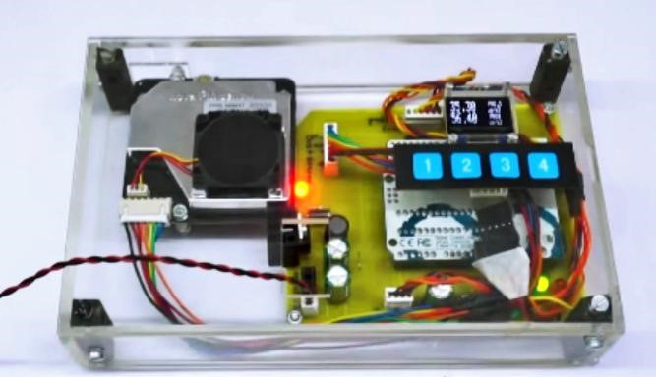

Conclusion:

Air quality monitoring using IOT offers real-time data collection and analysis, enabling prompt pollution control measures. It enhances public health by providing accurate air quality information. IOT sensors and data analytics improve the efficiency of air quality management systems. This technology helps identify pollution sources, aiding in targeted interventions. Overall, IOT-based air quality monitoring contributes to cleaner and healthier environments.

